

FHGW User Guide

Version History
Version | Date | Description of change | Author
1.0 | 15/01/2026 | Initial Draft | Itay Even
Table 1: Version History

Key stakeholders
Role | Stakeholder's Name | Approvers | Reviewers
Table 2: Key stakeholders

Contents
Version History 2
Key stakeholders 2
Contents 3
1 References 4
2 Installing the Setup 4
2.1 DU Install 4
2.2 Physical Connection to the FHGW 5
2.2.1 Serial Connection (USB) /Direct SSH via Eth Connection: 5
2.2.2 Install Model and Version 7
2.2.3 Map Connection 9
3 Radio Configuration 10
4 Download and config L1 and L2 12
4.1 Download new version 12
4.2 Run L1 and L2 15
5 Summary Commands 16

References
Ref | File Name
[1] | VVDN FHGW - Full Bring Up Guide updated 7.docx
[2] | RCT 7.x How to install the ISO.docx
[3] | B41 Integration - GreenRan - Confluence

Installing the Setup

DU Install
- Connections …
- First Install the ISO according to:
RCT 7.x How to install the ISO.docx

The User Config should be as follows:
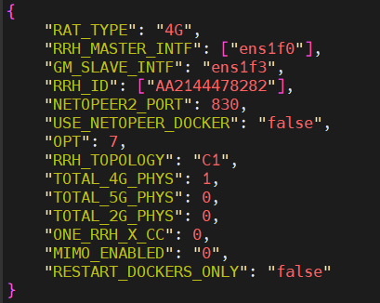

Where:
- RRH_MASTER_INTF: RRH connection port (must be list type)
- GM_SLAVE_INTF: grand master connection
- RRH_ID: name for the RRH, doesn’t matter which name (must be a list type)
- TOTAL_4G_PHYS: as to be as the number of RRH in the list

DU Netopeer Configuration
To enable configuration via Netopeer, the required configuration files must first be prepared and available on the DU. Therefore, perform the following steps:
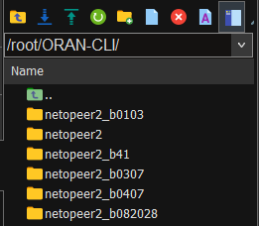
- Download the ORAN-CLI folder found in the link: ORAN-CLI
- Connect to the DU
- cd /root
- copy the ORAN-CLI folder to /root path:
- Give full permission to the folder:
chmod -R 777 ORAN-CLI/

Physical Connection to the FHGW

Serial Connection (USB) /Direct SSH via Eth Connection:
Once all physical connections are done and board is powered up, follow the directions below. We will use MOBAxTerm in this guide, but you may use other apps as well.

USB Serial port
Detect the relevant COM port in your NUC (you may use the windows Device Manager).

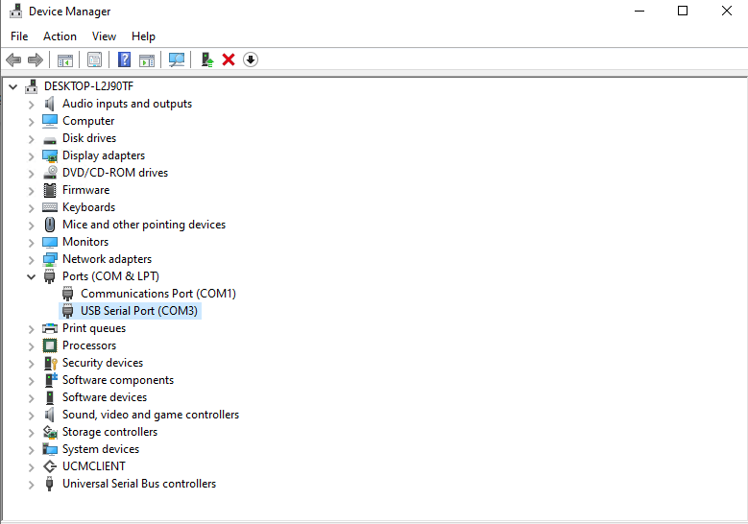

Open MobaXterm and create a new Session for a serial connection:
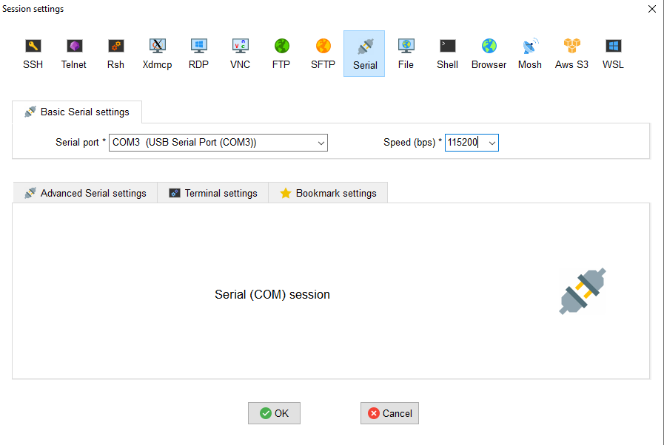

use the default settings - except for the speed which should be set to 115200 bps.
Note the COM number might change between PCs.

Try to access the COM port. Once the window opens, press “Enter” a few times.
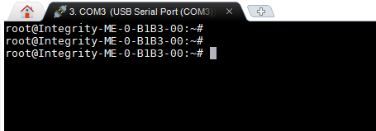

Onboard Ethernet port:
If you already connected to the ethernet port, you can use “ifconfig” command to see eth0 address (the board default IP is 192.168.1.10)
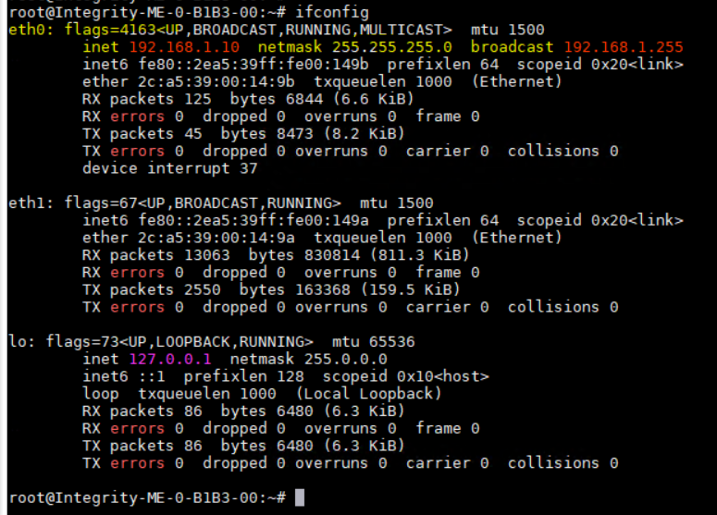

If not, open the Network and Sharing Center:
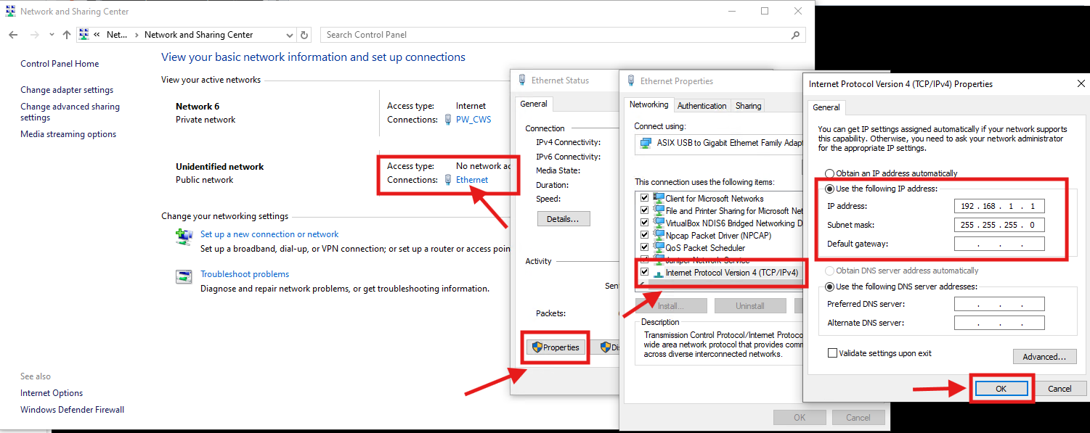

Ethernet à Properties àInternet Protocol Version 4 (TCP/IPv4) à Fill the IP address and the Subnet mask:
IP address: 192.168.1.1
Subnet mask: 255.255.255.0
If everything works, you should be able to ping the board IP and connect to it via SSH, from MOBA with Username:root, password:root

Install Model and Version
First, you should understand which band do you work with, for more information about Model, can find on the link: Model Name structuring - Product Management - Confluence
In case we work with band 3, I chose to work with Model name “Integrity-ME-0-B1B3-00”.
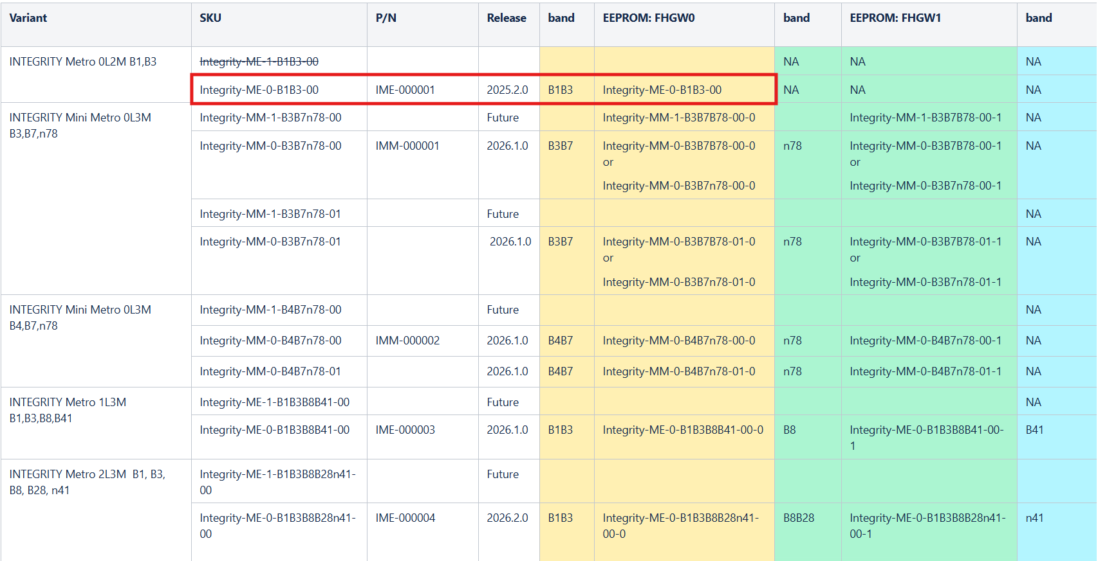

Model installation
- Run this command from the FHGW board to flash the model name:
  - For Band 1 and Band 3:
flash_eeprom <<< $'vvdnru@eeprom\n9\nIntegrity-ME-0-B1B3-00\n10\n20\n'
  - For Band 1 and Band 3 (AAU 4 band):
flash_eeprom <<< $'vvdnru@eeprom\n9\nIntegrity-ME-0-B1B3B8B41-00-0
n10\n20\n'
  - For Band 41:
flash_eeprom <<< $'vvdnru@eeprom\n9\Integrity-ME-0-B1B3B8B28n41-00-2\n10\n20\n'
  - For Band 41 (AAU 4 BANDS):
flash_eeprom <<< $'vvdnru@eeprom\n9\ Integrity-ME-0-B1B3B8B41-00-2\n10\n20\n'

- For Model Installation through Automation, do the following:
  - cd /run/media/mmcblk0p4
  - touch flash_eeprom_<band>.sh
  - vi touch flash_eeprom_<band>.sh
  - press “i” and copy and paste the follow in the file:
flash_eeprom
vvdnru@eeprom
9
Integrity-ME-0-B1B3B8B28n41-00-2
10
20
END
  - press “Esc”, then “:wq”

  - For Band 1 and Band 3: touch flash_eeprom_b0103.sh
flash_eeprom
vvdnru@eeprom
9
Integrity-ME-0-B1B3-0010
20
END
  - For Band 41: touch flash_eeprom_b41.sh
flash_eeprom <<END
vvdnru@eeprom
9
Integrity-ME-0-B1B3B8B28n41-00-2
10
20
END

Version installation
    - Open Artifactory: Artifactory - Parallel Wireless
    - Search for the newest version in the release under pw-products/ru-app/release/REL_<newest version>/< newest version>/ruapp/
      - Release: Artifactory - Parallel Wireless
    - Choose the end file of the wanted version, in our case b0103.zip:
      - For example – Band 1 and Band 3:
https://pwartifactory.parallelwireless.net/artifactory/pw-products/ru-app/release/REL_2025.4.x/20251125.2050-4a7799f1/ruapp/PWAAU-2025.4.1-100-g4a7799f1-b0103.zip
      - For example – Band41:
https://pwartifactory.parallelwireless.net/ui/native/pw-products/ru-app/release/REL_2026.1.x/20260201.0731-e8cc84d7e/ruapp/PWAAU-2026.1.0-100-ge8cc84d7e-b41.zip
    - Download the zip file to the computer
    - Connect to the board
    - cd /run/media/mmcblk0p4
    - Upload the version to the folder
    - ./upgrade.sh <FW> 0
      - Example: ./upgrade.sh PWAAU-2026.2.0-100-g9176b24bd-b0103.zip 0
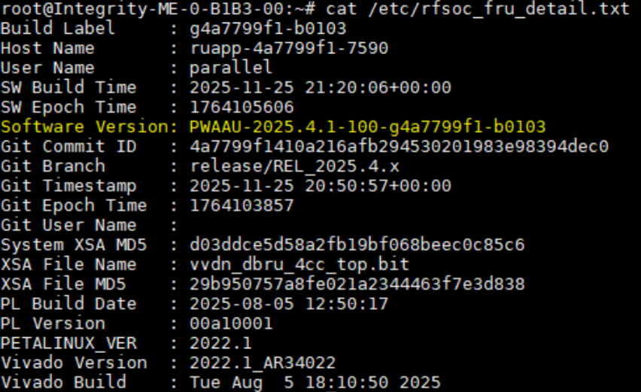
    - To see if the version was installed: cat /etc/rfsoc_fru_detail.txt

    - To see PTP synchronise: tail -f /var/log/synctimingptp2.log
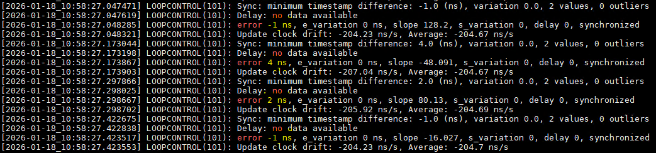
The result should show synchronized and small errors (up to $\sim 10ns$ ).

Map Connection
For Band 1 and Band 3:
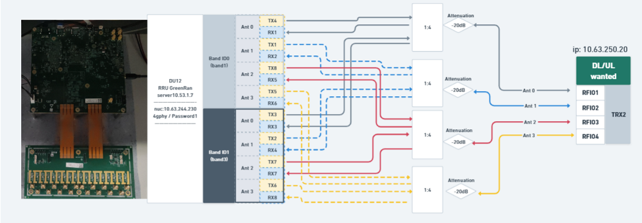

For Band 8:
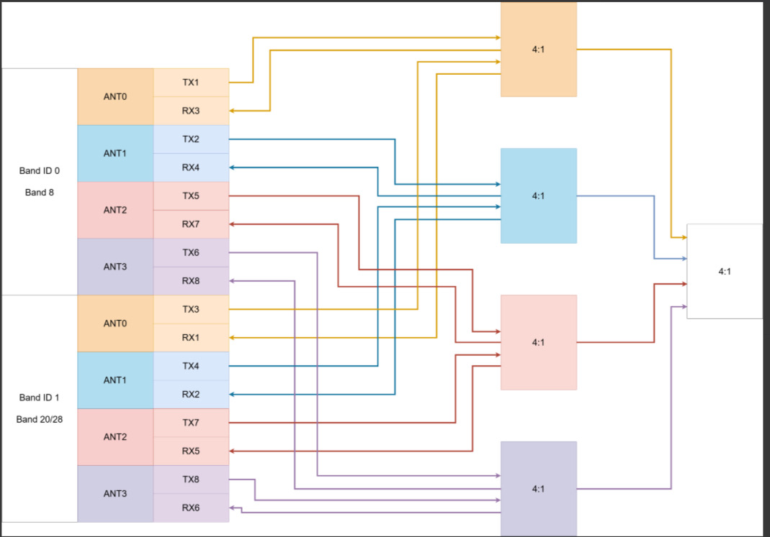

For Band 41:
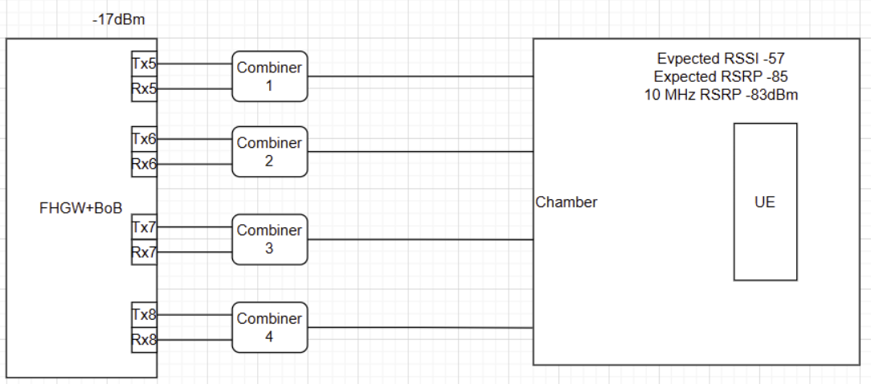
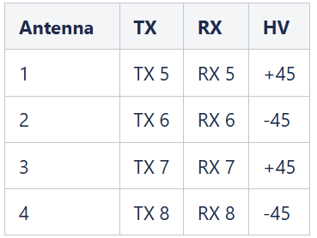

Radio Configuration
- Connect to the RRH through the NUC with the serial connection
- write “ifconfig” command to see the SSH connection:
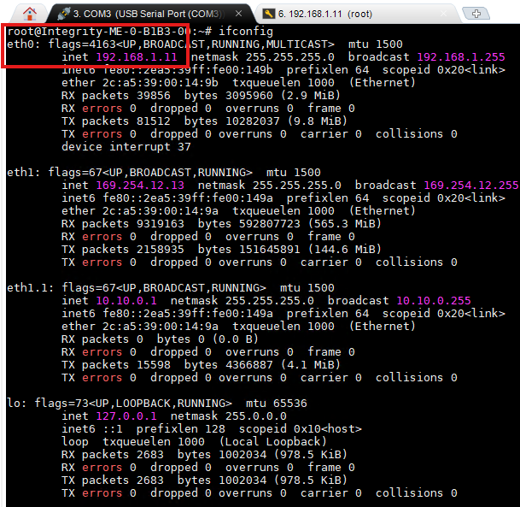
In this is example the IP SSH is 192.168.1.11
- connect to RRH through SSH: 192.168.1.11 root/root
- cd /etc/configs
- We have many xml files, but we are interested in few:
  - Integrity xml files:
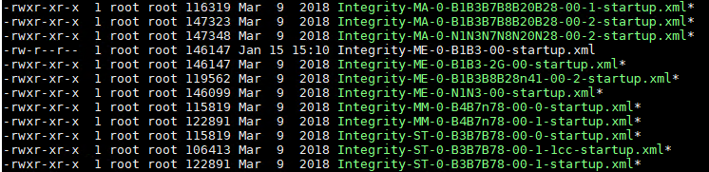
The one we interest with is the “Integrity-ME-0-B1B3-00-startup.xml”.
This xml is defined with default parameters (in default all the carriers are inactive)
  - The Active xml files:
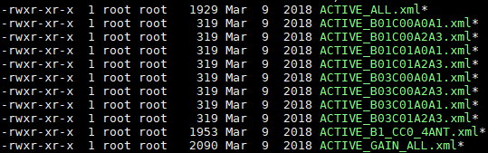

To active the carriers: run the relevant Active xml (Active all will active all the carriers).

- open the relevant configuration file:
For band 1 and band 3: Integrity-ME-0-B1B3-00-startup.xml
For band 41: Integrity-ME-0-B1B3B8B28n41-00-2-startup.xml
and edit the following:
  - DU mac address according to the DU mac:
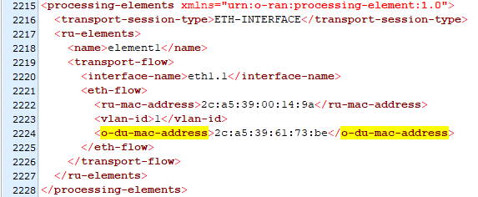
    - search for “o-du-mac-address” and edit the mac. To get the DU mac address
      - connect the DU through SSH
      - ip link show
      - take the mac address according to the port connection of the RRH, in the example bellow the port connection is “ens1f0” and the mac address is: “2c:a5:39:61:73:be”
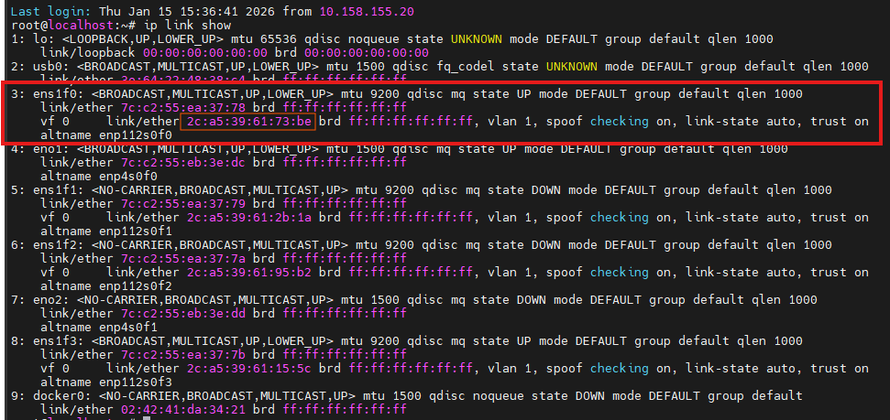
    - change the bandwidth and frequencies (if needed) in the <tx-array-carriers> and <rx-array-carriers>
look in the structure name: $\underset{ band number \left(3\right)}{\underbrace{B03}}\underset{num of carrier (0)}{\underbrace{C00}}\underset{num of antennas (0\&1)}{\underbrace{A0A1}}$
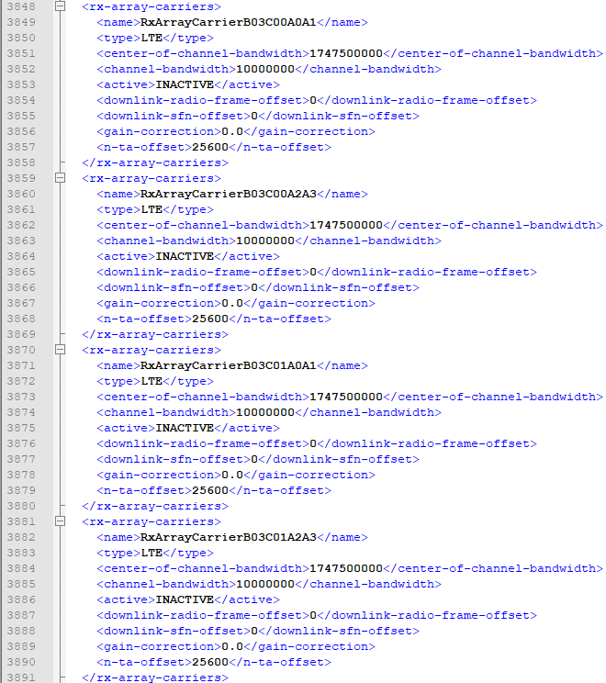
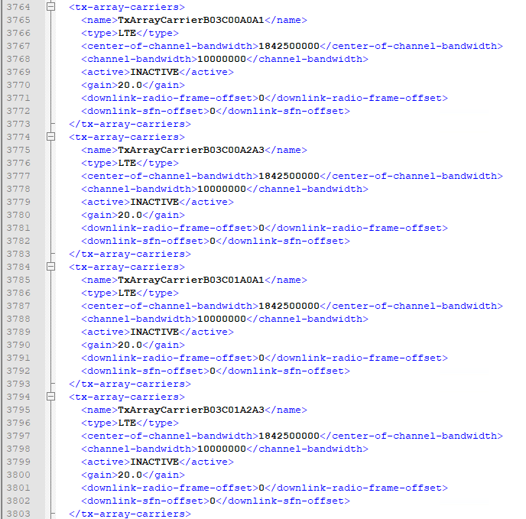

- cd /etc/configs/personalities
- open the “Integrity-ME-<band>-pw.json”:
For band 1 and band 3: “Integrity-ME-0-B1B3-00-pw.json”
For band 41: “Integrity-ME-0-B1B3B8B28n41-00-2-pw.json”
- edit the “midboards” in the “is-available” to false.
This config the FHGW not to use the BOB (Breakout Board) which used in the AAU.
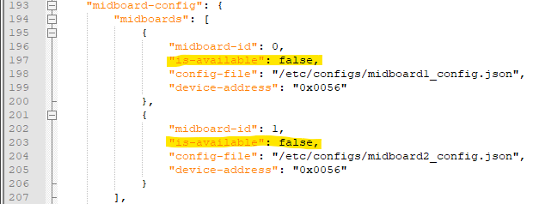
- Then do reboot

Re-offset configuration
- open /etc/configs/personalities/Integrity-ME-0-B1B3B8B28n41-00-2-pw.json
- Find line "re-offset: [4308, 4308, 4308, 4308]" – here is example for using 10MHz
- Change re-offset values according to list below
BW | PRACH Offset | Re-Offset
5 | 14 | 1284
10 | 37 | 4308
15 | 62 | 7908
20 | 86 | 11220
Note:
Please pay attention all integration procedure done for no CA in case of CA mode prach offset values nay be different and the re-offset should be calculated according to formula below:
$$X=\left(Prach offset-\left(\frac{MAX PRB}{2}\right)\right)+3$$
$$ReOffset=\left(X∙288\right)-12$$

Reboot the unit

Netopeer configuration

Running Netopeer through RRH:
      - connect to the RRH through the NUC
      - cd /etc/configs - not required, just for ease of viewing files
      - netopeer2-cli
      - connect
      - yes (if needed)
      - root (password)
      - to run files, use the command:
edit-config --target running --config=/etc/configs/<file.xml>

Running Netopeer through DU:
      - connect to the DU
      - cd /root/ORAN-CLI- not required, just for ease of viewing files
      - netopeer2-cli
      - connect --host <RRH_IP> --login root
      - yes (if needed)
      - root (password)
      - to run files, use the command:
edit-config --target running --config=/<path>/<file.xml> --rpc 40

Examples for running files:
From RRH:
edit-config --target running --config=/etc/configs/Factory_XMLs/ACTIVE_CC0_B1B3.xml
From DU:
edit-config --target running --config=/root/ORAN-CLI/netopeer2_b41/INACTIVE_ALL.xml --rpc 40
edit-config --target running --config=/root/ORAN-CLI/netopeer2_b0103/INACTIVE_ALL.xml --rpc 40

Download and config L1 and L2

Download new version
- Go to antifactory: Artifactory - Parallel Wireless
- Go to Artifacts pw-products
- Looking at the relevant folder:
  - For pw: generic-4g.phy
  - For flex-run: vru-4g-phy
- develop
- Choose the last release folder
- Copy URL to file
  - For pw: centos.tgz ending
  - Flex-run: debug.tgz ending
- Connect to ilks-bastion and download the new version: wget <version>
- In same way download the testmac.tgz:
  - Found in the Artifacts: pw-products à vru-4g-phy à <version> àtestmac.tgz ending
  - Copy URL to file
  - Connect to ilks-bastion and download the new version: wget <version>testmac.tgz
- Copy both to the share folder: opt/pw-share/pods/phy/phynode01/host
  - scp <version> <version.testmac.tgz> root@10.166.60.37://opt/pw-share/pods/phy/phynode01/host
  - If it fails, run: ssh-keygen -R 10.166.60.37 then try again
- Connect to the Server: 10.166.60.37
- Go to the docker: phy
- Create new directory for your version in 4gphy:
  - cd /staging/4gphy
  - mkdir <folder_name>
- Get into the new folder: cd /staging/4gphy/<folder_name>
- Copy to the version file and the testmac from the share folder "host" to the new folder:
- cp /opt/pw-share/pods/phy/phynode01/host/<version> <version.testmac.tgz> /staging/4gphy/<folder_name>
- Extract both files: tar -xvzf <file_name>
- If Flex-run:
  - cd /staging/4gphy/<folder_name>/libs/vru-fh
  - mv libxran.so libxran_orig.so
  - mv libxran_clnt.so libxran.so
- Now we need to config our new version according to our server
- To see the number of cores: lscpu
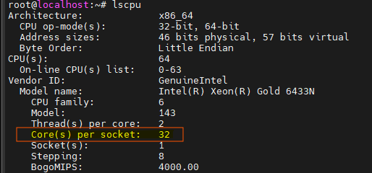
In this case the number of cores is: 32
- To see which core are occupied, so we will prevent overlaps, run:
cat /opt/cpualloc.json
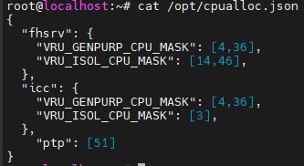

- cd /staging/4gphy/<folder_name>/bin/lte/l1
- Edit oammgrconfig.xml: vi oammgrconfig.xml
  - <totalNumOfCores> 32 </totalNumOfCores> (in our case 32)
  - <nonRtCores> 1,33 </nonRtCores>
- The second must be 1+num of cores
  - <l1RtCores> 5,6,37,38 </l1RtCores>
- Same Idea (5,6, +num of cores)
  - <fhServiceId> 1 </fhServiceId>
Under <fhIf>,<inst> - change the first block:
  - <enabled> true </enabled> - (should be like it in default)
  - <HW_Ants> 4 </HW_Ants> (If num of antennas is 2 change to 2)
  - <type> oran-spl7.2 </type>
  - <rrhType> RRU-5820D51,P46N48T4R4Y03 </rrhType>
  - <oran-spl7.2>:
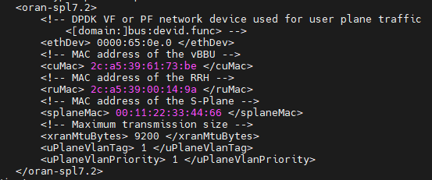
- cuMac: same mac we found earlier (ip link show in the DU according to the RRH port connection)
- ruMac: write arp -n
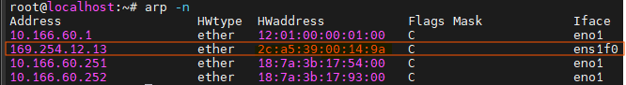
Take the mac address according to the RRH connection port, in this case port ens1f0: 2c:a5:39:00:14:9a
  - For using dual-band mode, you should return on steps 4-9 for the second block
- Edit phycfg.xml:
  - <AppRunMode> 0 </AppRunMode> (from 1 to 0)
  - <apiSniffer> false </apiSniffer> (from true to false)
- Edit testmac_cfg.xml:
  - cd /staging/4gphy/<folder_name>/bin/lte/testmac
  - vi testmac_cfg.xml
  - <PhyStartMode> 7 </PhyStartMode> (from 5 (option8) to 7(option 7.2))
  - Under <Threads>, change all <coreMask> to 10:
<coreMask> 10 </coreMask> (5 times)
  - In the end of the file, change the <bandSectorId> in each cell:
- <Cell0> represents cell number 0: config to 0 which is band 1
- <Cell1> represents cell number 1: config to 1 which is band 3

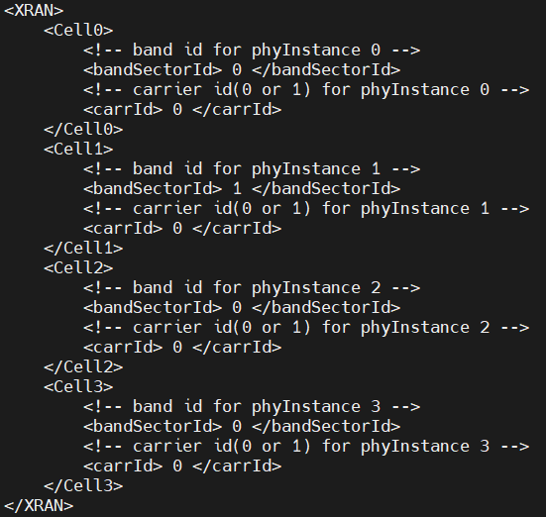
0: Band 1
1: Band 3

Run L1 and L2
M-Plane connectivity through netopeer2-cli
    - cd /etc/configs
    - netopeer2-cli
    - connect
    - Password: root
    - edit-config --target running --config=/etc/configs/<Active_file.xml>
      - edit-config --target running --config=/etc/configs/ACTIVE_ALL.xml
    - active all carriers
      - edit-config --target running --config=/etc/configs/ ACTIVE_B03C00A0A1.xml
    - active only band 3 carrier 0 ant 1 and ant 2
      - edit-config --target running --config=/etc/configs/d ACTIVE_B03C00A2A3.xml
    - active only band 3 carrier 0 ant 3 and ant 4

To see if the active works well:
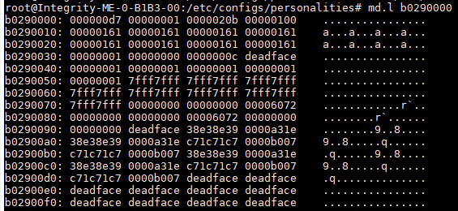
Run “md.l b0290000”:
Band 1
Band 3
$$\overset{ant 0}{\overbrace{a…}}\overset{ant 1}{\overbrace{a…}}\overset{ant 2}{\overbrace{a…}}\overset{ant 3}{\overbrace{a…}}$$
$$'a^{'}: active$$
$$'.^{'} : not active$$

Run L1:
  - Connect to DU server
  - phy
  - cd /staging/4gphy/<version>/bin/lte/l1
    - Edit: "phycfg.xml" (Flex-run) or 'param_enb' (pw)
    - Run: ./l1.sh -rct (Flex-run) or LD_LIBRARY_PATH=. ./enb_app e2e param_enb.json (pw)
Run L2:
  - Connect to DU server
  - phy
  - cd /bin/lte/testmac
  - Run: ./l2.sh

To see Power monitor:
Connect to RRH through SSH and run:
for i in {0..3}; do power-monitor 0$i dl; done

Time Management

Overview ($DU↔RU↔Antenna$)
- O-DU performs baseband PHY processing and exchanges data with the O-RU through the fronthaul (FH) interface.
- C-plane carries control/configuration information (green in diagram).
- U-plane carries the IQ samples of the OFDM symbols (blue in diagram).
- O-RU processes the received data and performs RF transmission or reception through the antenna port.
The system is synchronized using the air interface timing reference: $t=0$
which corresponds to the time when symbol #n is transmitted (DL) or received (UL) at the antenna (shown at the right side of the diagram).

Because of fronthaul delay and RU/DU processing time, packets must be sent earlier than the air interface event.

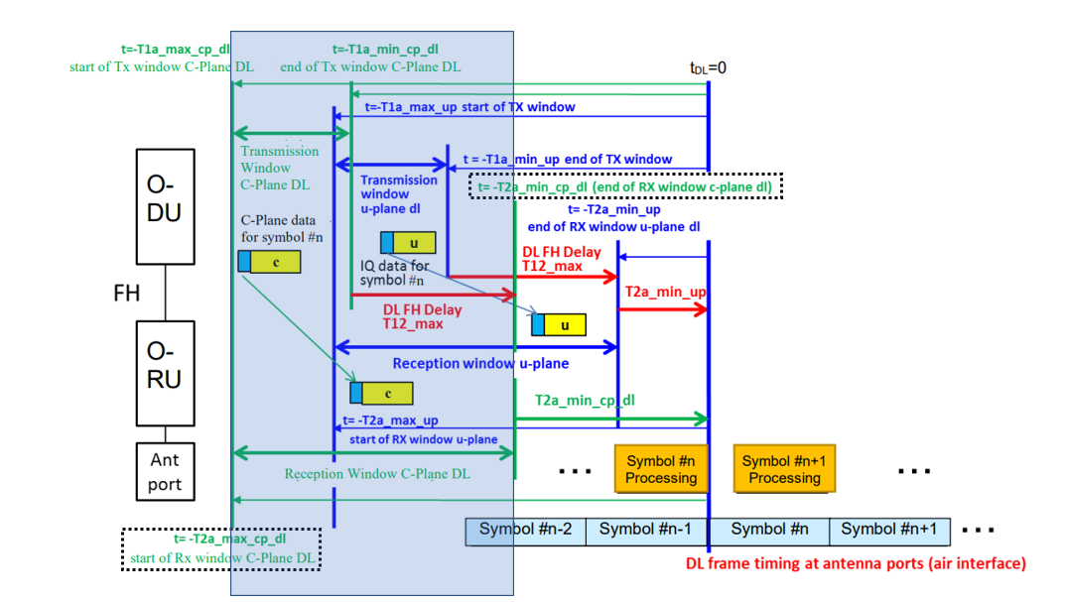
Downlink Operation (DU → RU → Antenna)
Order: C-plane (green) → U-plane (blue) → RU processing → RF transmission

Sequence
    - DU sends C-plane DL (green in the diagram) - configuration for symbol #n.
    - DU sends U-plane DL (blue in the diagram) - IQ samples for symbol #n.
    - Data travels through the fronthaul with delay T12 (red arrows labelled DL FH Delay T12_max).
    - RU receives packets inside the reception window (blue reception window).
    - RU performs symbol processing (yellow blocks “Symbol #n Processing”).
    - At $tDL=0$, the RU transmits symbol #n at the antenna (vertical blue line at the air interface).

The RU defines the reception window for incoming IQ packets:
$$[T2a_max_up , T2a_min_up]$$
These parameters appear in blue in the diagram and define the U-plane reception window.
To ensure packets arrive inside that window, the DU transmits inside a transmission window:
$$[T1a_max_up , T1a_min_up]$$
These limits appear in blue above the U-plane transmission window.
The relationship between DU and RU timing depends on the maximum fronthaul delay:
$$T12_max$$
which is shown in red in the diagram.

Timing relationship:
T1a_max_up = T2a_max_up
T1a_min_up = T2a_min_up + T12_max

Meaning:
- The DU transmission window (blue) is calculated so packets arrive inside the RU reception window (blue).
- The fronthaul delay (red) shifts the DU transmission earlier in time.

Downlink Parameters
Parameter | Meaning | Diagram reference
tDL | Time when symbol #n is transmitted on the antenna | Vertical blue line at air interface
T2a_max_up | Earliest RU reception time for U-plane packets | Blue - start of RX window
T2a_min_up | Latest RU reception time for U-plane packets | Blue - end of RX window
T12_max | Maximum fronthaul delay | Red arrow (DL FH Delay)
T1a_max_up | Earliest DU transmission time | Blue - start of TX window
T1a_min_up | Latest DU transmission time | Blue - end of TX window
T2a_cp_dl | C-plane DL reception timing | Green arrows
T2a_cp_ul | C-plane UL timing parameter | Green timing markers

Uplink Operation (Antenna → RU → DU)
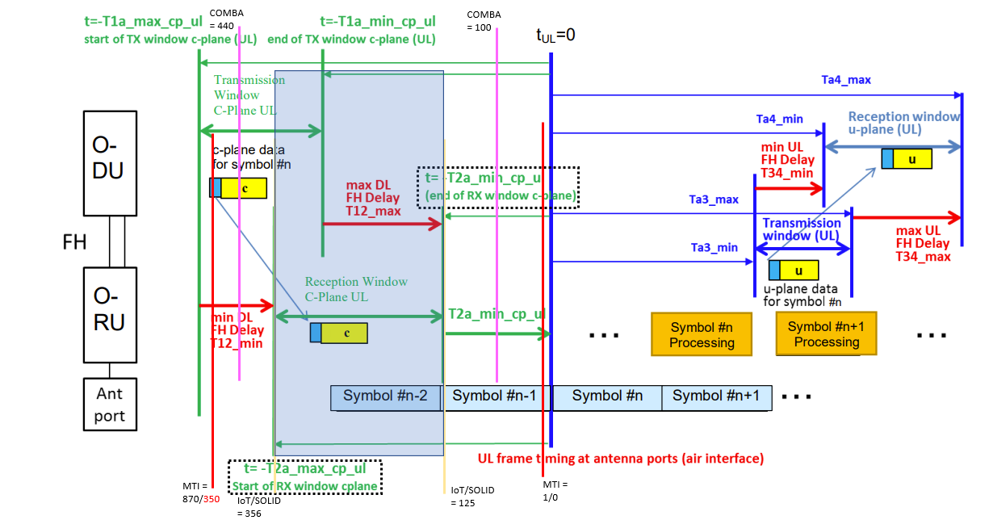
Order:
RF reception → RU processing → U-plane UL → DU processing

In uplink, the air interface event happens first: the UE’s UL symbol is received at the RU antenna port. Only after that, the RU can forward the received IQ samples over the fronthaul to the DU.
Therefore, UL timing windows (U-plane) appear after the reference point $t_{UL}=0$.
- O-RU: receives UL on the antenna, performs front-end/baseband prep, and sends UL U-plane IQ toward the DU.
- O-DU: receives UL U-plane IQ and continues UL baseband processing (Higher PHY/MAC).

Uplink Operation Sequence
- Symbol #n received at antenna at $t_{UL}=0$ (air-interface reference).
- RU processes the received symbol.
- RU sends U-plane UL IQ packets within RU TX window (Ta3_min... Ta3_max - blue).
- Packets experience UL FH delay (T34_min... T34_max - red).
- DU receives packets within DU RX window (Ta4_min... Ta4_max - blue).
- DU performs symbol processing for UL (continuing the PHY chain).

Timing relationships
Ta4_min = Ta3_min (considering DL FH Delay T34_min which is 0)
Ta4_max = Ta3_max + T34_max

Downlink Parameters

Parameter | Meaning | Diagram color
$$t_{UL}=0$$ | Air-interface reference: time UL symbol #n is received at RU antenna | Blue vertical reference
Ta3_min | Earliest RU transmission time for UL U-plane packets | Blue
Ta3_max | Latest RU transmission time for UL U-plane packets | Blue
T34_min | Minimum UL fronthaul delay RU→DU | Red
T34_max | Maximum UL fronthaul delay RU→DU | Red
Ta4_min | Earliest DU reception time for UL U-plane packets | Blue
Ta4_max | Latest DU reception time for UL U-plane packets | Blue
Reception window U-plane (UL) | DU-side allowed arrival window for UL IQ packets

FHGW Limitation

FDD – Band 3 and band 1:

 | Max Output Power [dBm] | Sensitivity Point [dBm] | Power validation in the digital
Band 1 | -16.7 | -69 | Power Monitor: -16.7dBFS  -8.8dBFs [dpd_i]
Band 3 | -15.7 | -69

TDD – Band 41
Stack limitations:
- Dynamic CFI not supported for TDD.
  - please change CFI to 1 for 1 UE setup or CFI 2 for more UEs
- Only PRACH config index 4 supported.
  - Changing it to different values will not be affected
- The system supports only TDD Frame Configuration 2 and Special Subframe Configuration 6. Changing these parameters to other values will not affect system behavior.

FHGW limitation
- TA with correct Ntaoffset 20us is 4
GRDEV-5757[GreenRAN][B41 TDD] Configuration of "ul_delay" (Ntaoffset) parameter to 20us caused to TA 4 PRACH
- CQI and DL TP degradation on top of band (EARFCN 41390) but DL TP stay pass TP KPI
GRDEV-6218[GreenRAN][B41 TDD] CQI and DL TP degradation on top of band (EARFCN 41390) but DL TP stay pass TP KPI

 | Max Output Power [dBm] | Sensitivity Point [dBm] | Power validation in the digital
Band 41 | -23 |  | Power Monitor: -16.7dBFS  -8.8dBFs [dpd_i]
Test_Report_REL_2026_1_X.xlsx

IQ-Playback

Instead of using the PHY for testing radio performance, a simulation-based approach can be used to demonstrate the downlink (DL) signal. This method is referred to as IQ Playback.
To use this feature, the simulation signals must first be loaded onto the RU. Perform the following steps:
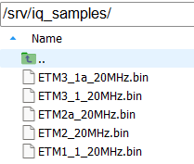
        - Download your relevant IQ signals, found on the link: IQ_Signals
        - Connect the RRH
        - cd /srv
        - mkdir iq_samples/
        - copy the require signals to the folder “iq_samples”

For running IQ-Playback, do the following:
    - /usr/bin/cli-manager &
    - telnet localhost 8888
    - Username: root
    - Password: root
    - iq_playback /srv/iq_samples/<file.bin> 0 0 0
where the first 0 represents the numbers of antennas:
- 0 – ant1
- 1 – ant2
- 2 – ant3
- 3 – ant4
- 255 – all antennas

Examples:
iq_playback /srv/iq_samples/ETM1_1_20MHz.bin 0 0 0

    - for stop: iq_stop

To see the IQ samples, we will use the power monitor command:
for i in {0..3}; do power-monitor <path_number>$i dl; done
where the <path_number> represents:
- 0 – cell_id:0, carrier_id: 0
- 1 - cell_id:0, carrier_id: 1
- 2 – cell_id:1, carrier_id: 0
- 3 - cell_id:1, carrier_id: 1

Examples:
for i in {0..3}; do power-monitor 0$i dl; done
for i in {0..3}; do power-monitor 2$i dl; done

Summary Commands

Command | Description
Debug commands
cat /run/media/mmcblk0p4/fhgw.log | RRH configuration log
cat /run/media/mmcblk0p4/fhgw.log | grep -E 'DAC Channel|TRX Carrier|sync_state:|availability:|Fault:|LPHY_THRD|dev_idx|center frequency|Carrier Placement' | RRH configuration log – specific parameters
tail -f /var/log/synctimingptp2.log | PTP Status
cat /run/media/mmcblk0p4/fhgw.log | grep -E 'DAC Channel|TRX Carrier|sync_state:|availability:|Fault:|LPHY_THRD|dev_idx|center frequency|Carrier Placement'
fw_printenv selected_slot | Watch active slot
fw_setenv selected_slot <num> | Change to slot
md.l b0290000 | Register status
sysrepocfg -X |grep active | Active / Not Active status
sysrepocfg -X |grep band | Which band are defined
sysrepocfg -X | grep -E "active|channel-bandwidth" | Which bandwidth and Active/not Active
for i in {0..3}; do power-monitor 0$i dl; done | Open power monitor
Static Configuration Status
cat /opt/vfs-data.json | Show pci and mac for physical ports
cat /etc/configs/Integrity-ME-0-B1Bc3-00-startup.xml | grep du-mac | Directly see the RRU mac
cat /etc/rfsoc_fru_detail.txt | Version settings
cat /opt/cpualloc.json | Show which cores is occupied
cat /opt/version.txt

IQ playback
cd /srv/iq_samples/ | Iq-playback folder
/usr/bin/cli-manager & | Open iq-playback
telnet localhost 8888 | Connect to localhost in the iq-playback
iq_playback /srv/iq_samples/<file.bin> 0 0 0 | Run iq signal script
iq_stop | Stop script
Netopeer
netopeer2-cli | Open Netopeer application
connect (password: root)
edit-config --target running --config=/etc/configs/Factory_XMLs/ACTIVE_CC0_B1B3.xml | Run file in Netopeer
connect --host 169.254.12.13 --login root | Connect to Netopeer through DU
edit-config --target running --config=/etc/configs/ACTIVE_B41C00A0A1.xml
edit-config --target running --config=/etc/configs/ACTIVE_B41C00.xml
edit-config --target running --config=/etc/configs/Factory_XMLs/SetBW_B1B3_BW15.xml

